***Online Food Ordering System***

**Introduction (Description):**

The main purpose of online food ordering system is to make ordering easy to the user which can order form a long distance restaurant the food he wants and get the bill for that operations then put his name , his number and his address to make it easy for delivering food to him.

**Class diagram:**

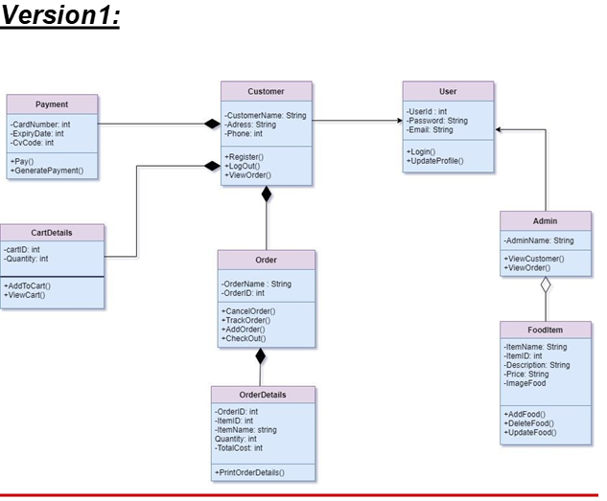

***Version 2:***

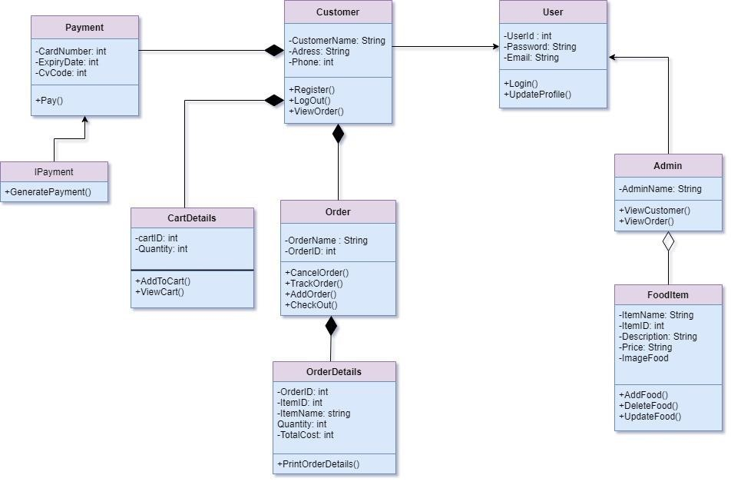

***Version 3:***

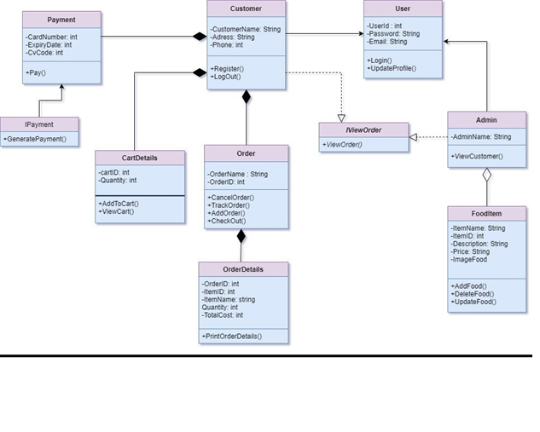

***Version 4:***

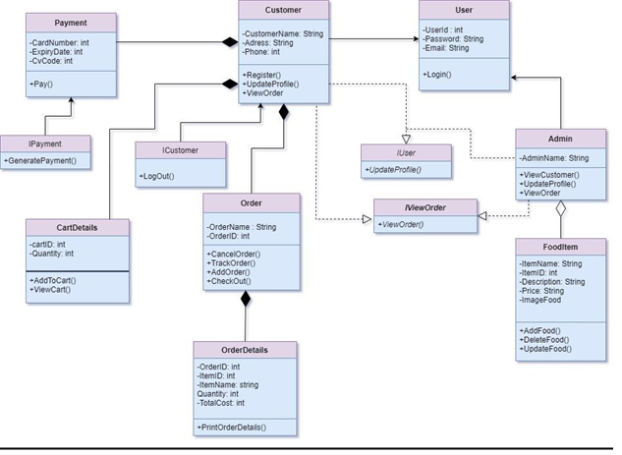

**Database Schema :**

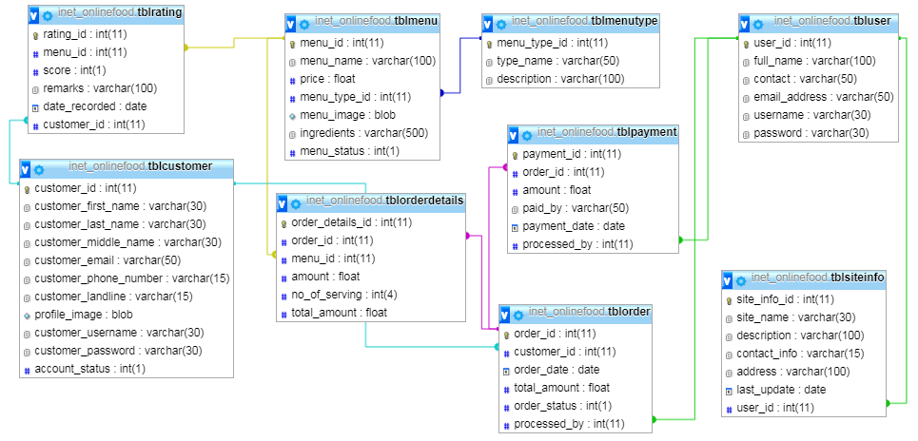

**Design Pattern :**

**Module 1 User can search different restaurants- (Interpreter Design Pattern):**

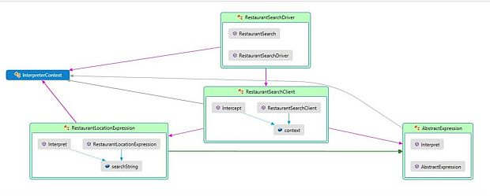

**Module 2 User Sees Menu - Iterator Pattern**

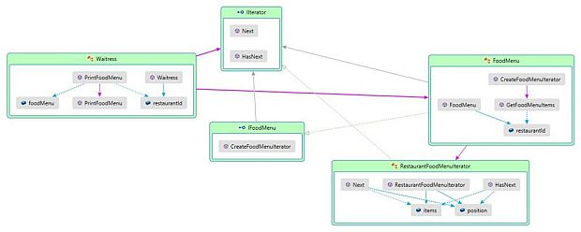

**Module 3 Adding food items for ordering - Builder Design Pattern**

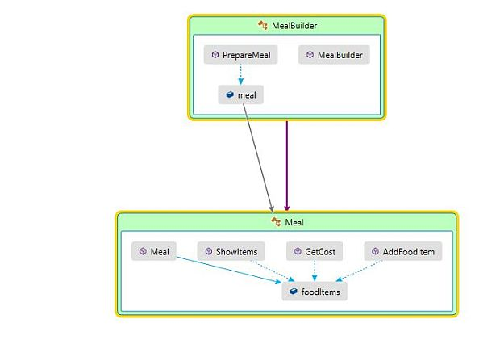

**Module 4 Order or Cancellation of Food or Meal - Command Design Pattern**

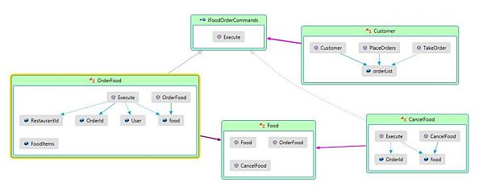

**Module 5 Track an Order in Real Time - Observer Design Pattern**

